Spojená škola Svätej Rodiny, Gercenova 10, 851 01 Bratislava

Anglický jazyk

Pracovný list

Téma: Domov a bývanie

Spracovala: Mgr.L.Kotuličová

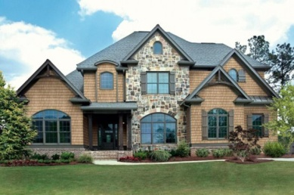
READING AND SPEAKING

HOUSE AND OUR HOME

Living in towns and cities has advantages and disavantages. On the one hand, there are many possibilities for jobs, education, sports and social life. There are many cultural events there, such as concerts, operas and theatre performances. People can visit cafés, pubs and night clubs. There are many shops, shopping malls and hospitals too.
On the other hand, city inhabitants live in polluted, noisy, crowded and hectic places. There is often a lot of mess and dirt in the streets. Many city people live in housing estates, which is not an ideal place for children. There is also a high level of crime.
Many Slovaks live in flats. Some of them have cottages in the mountains where they like spending their weekends. The British prefer to live in houses. There are several types of houses in Britain, for example terraced houses which are built in a row, semi-detached houses that have one common wall, detached houses that stand by themselves and bungalows. Some Slovak houses are big enough for two families – grandparents, their children and grandchildren.
The furniture in British and Slovak rooms is not different these days. The sitting room has a sette and armchairs, a wall unit and a hi-fi system, television and a video, a bookcase and a coffe table. There is a carpet on the floor to make the room warm and comfortable. Most of the British houses have a fireplace because of cold weather. In the kitchen there are kitchen cupboards, a sink, a cooker, a fridge. There is also a table with chairs or stools. The floor in the kitchen is often tiled. Slovak families usually have their washing machine in the bathroom, the British in the kitchen. The bedroom has a double bed, built-in wardrobes, a dressing table with a mirror and a stool in front of the table.
In the USA an average American family live in a large house with many rooms. In American cities, many people live in downtown apartments (flats). Like the British, Americans do not usually stay in the some house their whole lives. Some families like to move to other parts of the country and change houses every ten years.

ANSWER THE QUESTIONS:
- What are the advantages of living in the country? Compare it with life in towns and big cities.
- What are the disadvantages of living in the countryside? Compare it with life in towns and cities.
- What types of houses can you find in Slovakia? Which one is your most favourite type?
- Talk about furniture which is usually placed in a kitchen, a living room and in a bedroom?
- Are there any differences between the life of an average American and a Slovak family?
- Describe your living room/bedroom.
- What is your favourite piece of furniture in your bedroom? Why? Describe it.
- Wher would you personally prefer to live in ten/twenty years´time?
- Is it easy to buy your own flat/house in your region?

Some useful phrases:
In the picture, there is/are..................................
In the picture, I can see a/some........................
It is built/situated somewhere in.........................
Inside the house, there is/are...........................
Outside the house, there is/are........................
The most beautiful/interesting/impressive part of the house is....................
I like/don´t like the house because..................................

A SPHERE

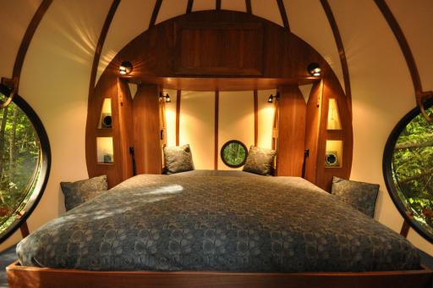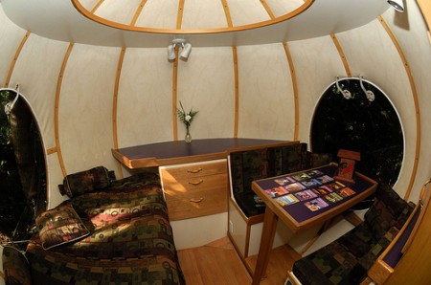

Describe the rooms in the pictures above. Say what the advantages and disadvantages of living at these places are.
Would you like to live in such a house? Why yes? Why not?

In my opinion the advantages are…………………………………………………………………………………………
……………………………………………………………………………………………………………………………………………..
…………………………………………………………………………………………………………………………………………….…………………………………………………………………………………………………………………………………………………
On the other side there are some disadvantages …………………………………………………………………
……………………………………………………………………………………………………………………………………………………………………………………………………………………………………………………………………………………………………………………………………………………………………………………………………………………………………………………………………………………………………………………………………………………………………………………………..

LISTENING and WATCHING
1.Before you watch:
Where do you live? Describe the house or the flat where you live. Are you satisfied with your home? Explain.
1B. Students are watching a video.

2.After you watch:
- Decide if the statements are true or false:

- The house is situated near Sao Paulo in Brazil......................
- Lucas lives with his wife .............
- The house was designed by Lucas´ father in the 80´s....................
- There are 3 floors in the house..........................
- All furniture is custom – made....................
- You can find there: 2 bedrooms, dining room, living room, bathroom, kitchen and 2 bathrooms.......
- The house is made of steel...................
- It is quite small to have o lot of visitors...............
- People passing by think that it is a radio station, a hotel or a night club.....................
- All of Lucas friends like the house very much........................

Do you like the house? Explain.

- You have been invited by Lucas to spend a week in his house. Write a letter to your friend describing where you are staying and what it is like living there.

.............................................................................................................................................................................................................................................................................................................................................................................................................................................................................................................................................................................................................................................................................................................................................................................................................................................................................................................................................................................................................................................................................................................................................................................................................................................................................................................................................................................................
.........................................................................................................................................................................................................................................................................................................................................................................................................................................................................................................................................................................................................................................................................................................................................................................................................................................................................................................................

VOCABULARY

1.Where can you find it?

Living room | kitchen | bathroom | bedroom | Kichen utensils | garden

mirror, chest of drawers, wardrobe, comb, toothbrush, toothpaste, wash basin, sink, alarm clock, towelrail, water tap, switch, coffee table, bedside table, ceiling, curtains, fireplace, mantelpiece. rug, carpet, tablecloth, cushion, pillow, vase, table mat, wallpaper, blanket, mattress, sheet, flowerpot, tiles, bunk bed, shower, bin, bath, toilet, walk-in wardrobe, soap dish, toilet bowl, chairs and table, light bulb, lamp, armchair, boolshelf, bookcase, sofa, blanket, eiderdown/ duvet, knife, fork, spoon, table lamp, desk lamp, cooker, oven, extractor hood, fridge, freezer, washing machine, dish washer, wood flooring, ceramic tile flooring, laminate floor, dressing table, chest of drawers, double bed, built in wardrobe, custom made bed, blinds or shades

2.COMPOUND WORDS

A Match a word in column A with a word in column B to form compound words.

column A | column B
Bath land  bed stair  cup work  door hand  dust flower | Bin rail  Board shop  Case spread  Lady room  Pot mat

B Fill the gap with the correct compound word.

- A.....................is known in the US as a garbage can.
- When Americans need to use the toilet, they ask where the.........................is.
- That plant is lovela, but I don´t care for the.....................................
- My father keeps all his DIY in the .......................................
- My mother keeps all the plates in the........................................
- My grandmother uses a..................................to cover the duvets and pillows.
- My grandmother can´t climb stairs without holding the.....................................
- John´s ......................................always gets angry when he falls behind with the rent.
- Wipe your dirty shoes on the ............................before you come in.
- There was a spiral..................................leading all the way to the tower.

3. Match the types of housing below to their descriptions.
TYPES OF HOUSES DESCRIPTIONS
semi-detached ......................  detached..............................  Block of flats.......................  Cottage................................  Chalet.................................  Tent....................................  Mansion..............................  Caravan..............................  Terrace...............................  Terraced-house.................. | - A building with lots of apartments in  - A small country house  - A house attached to one another  - A house which stands on its own  - A large country house  - A moveable place to live made out of waterproof material  - A moveable place to live on the wheels  - A row of houses joined together  - A small building in the garden of a house  - A holiday home, normally found in the mountains

- My words/structures to remember:
……………………………………………………………………………………………………………………………………………………………………………………………………………………………………………………………………………………………………………………………………………………………………………………………………………………………………………………………………………………………………………………………………………………………………………………………………………………………………………………………………………………………………………………………………………………………………………………………………………………………………………………………………………………………………………………………………………………………………………………………………………………………………………………………………………………………………………………………………………………………………………………………………………………………………………………………………………………………………………………………………………………………………………………………………………………………………………………………………………………………..

GIVING OPINIONS

A Describe houses in the pictures
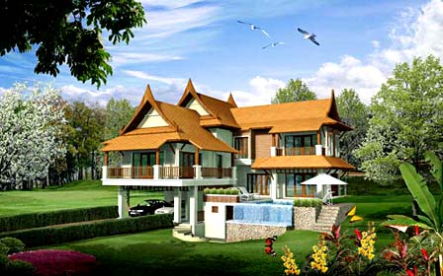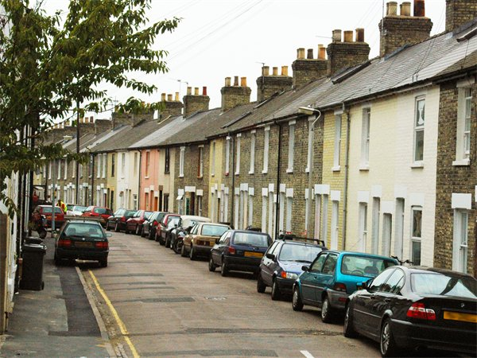

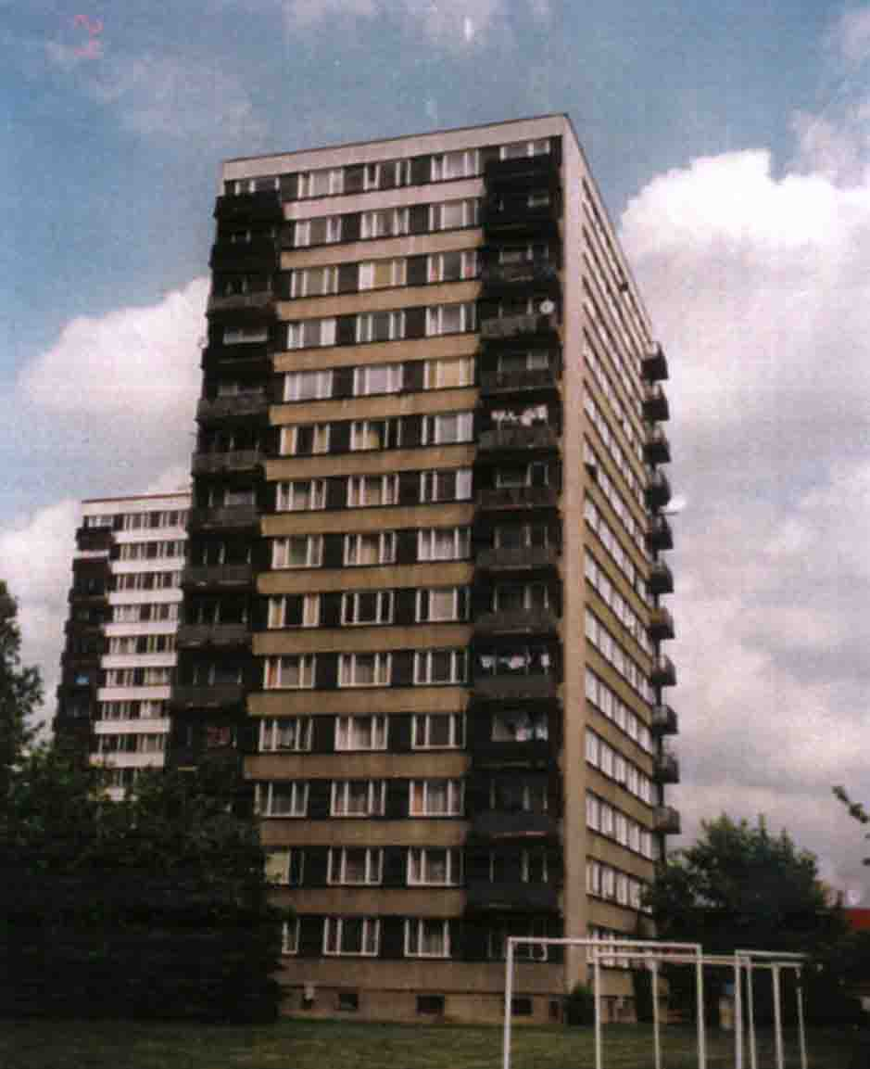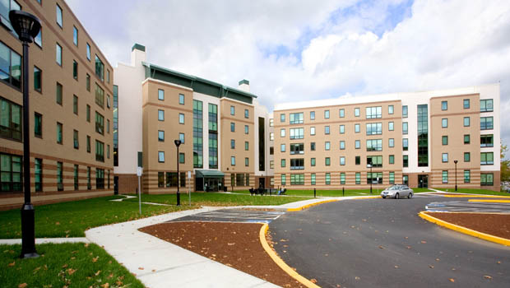

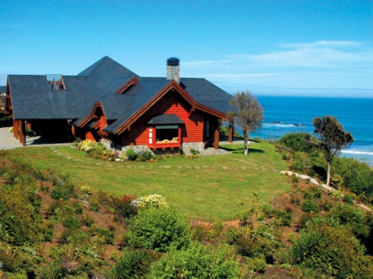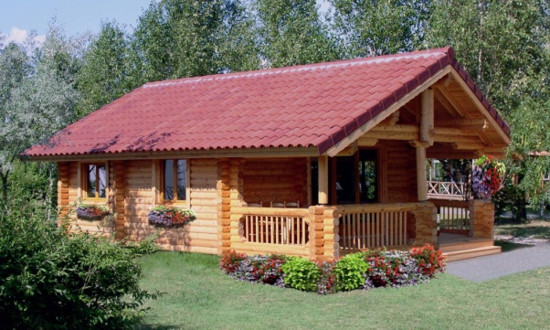

B Now compare and contrast the houses in the pictures above. Say what the advantages and disadvantages of living in these places are. Talk about public transport, schooling possibilities, social life, cultural events, shops and health care.

You can start like this:
There are advantages/disadvantages of…..
The first advantage/disadvantage is…
Another advantage/disadvantage is…
The biggest advantage/disadvantage is…
I prefer…
I think that…
I would say that…
In my opinion…
In the end I would say that…/ To sum up…../ Finally I think….
C Your family wants to sell a flat/house where you are living now. Your friend´s parents are interested in it and they are thinking about buying it. Describe it using the expressions below.
Well-situated  Not far from the city centre  A three-room flat  On the fourth floor  Good view over the town | Southern orientation  There is a lift  Good neighbours  Easy parking  Bus stop in a walking distance | Corner shop is opposite  Your school is 10 minutes´ walk  Sports facilities – football stadium, tennis courts and gym are nearby
Central heating  Balcony  Reconstructed bathroom | New windows,  safety entrance door  modern furniture | Light colours  Carpet and tiles on the floor  Built-in wardrobe
........................................................................................................................................................................................................................................................................................................................................................................................................................................................................................................................................................................................................................................................................................................................................................................
........................................................................................................................................................................................................................................................................................................................................................................................................................................................................................................................................................................................................................................................................................................................................................................
.......................................................................................................................................................................................................................................................................................................................................................................................................................................................................................................................................................................................................................................................................................................................................................................

WRITING

Design and describe your perfect house or flat. Follow the stages:

Stage 1
Design your house. Think about these things:
- Kind of house
- Materials
- Rooms
- Where
- Special features

Stage 2
Use your ideas to make a paragraph plan:
Paragraph 1: introduction – location / kind of house
Paragrapd 2: rooms – what rooms, where they are
Paragraph 3: special features of the house
Paragraph 4: conclusion – why you want tp live there

Stage 3
Now write the description of your house or flat.
Check your description for mistakes.
........................................................................................................................................................................................................................................................................................................................................................................................................................................................................................................................................................................................................................................................................................................................................................................
........................................................................................................................................................................................................................................................................................................................................................................................................................................................................................................................................................................................................................................................................................................................................................................
........................................................................................................................................................................................................................................................................................................................................................................................................................................................................................................................................................................................................................................................................................................................................................................
........................................................................................................................................................................................................................................................................................................................................................................................................................................................................................................................................................................................................................................................................................................................................................................

