Spojená škola Svätej Rodiny, Gercenova 10, 851 01 Bratislava

Konverzácia v anglickom jazyku

Pracovný list

Téma: Práca a zamestnanie

Spracovala: Mgr.L.Kotuličová

VOCABULARY

- Work in pairs. Discuss the following questions.

- What is your idea of a good job?
- Have you ever had a part-time job you didn´t like? What happened?
- What is „a good job“ in your opinion?

- Match each job in box A with a place in box B. More than one answer may be possible.

A | B
Cashier  Farmer  Mechanic  Photofrapher  Receptionist  Cook  Hairdresser  Miner  Pilot  Vicar  Dentist  Librarian  Musician  Porter  Waiter | Bank.......................................................................  Garage...................................................................  Studio.....................................................................  Kitchen...................................................................  Coal mine...............................................................  Cockpit...................................................................  Hotel......................................................................  Office.....................................................................  Surgery..................................................................  Salon.....................................................................  Field.......................................................................  Concert hall............................................................  Restaurant.............................................................  Church.....................................................................  Library.....................................................................

- Complete each sentence with a word from a box. Use the words more than once.

business job living work

- Jack makes his.......living.............. working as a journalist.
- She has just left to go to..................... , I´m afraid.
- They worked very hard and now they have their own .......................
- There are still nearly two million people without...............................
- The cost of ....................has risen greatly over recent years.
- Stop interfering! This is none of your ..............................!
- Lucy has a very good......................in international company.
- I can´t come out tonight. I have got too much .......................to do.
- Some .......................-men came and dug a hole in the road outside.
- An early ......................by Picasso was sold for £3,000,000.

4. Match the adjectives with phrases 1-20.

Ambitious, arrogant, assertive, bad-tempered, calm , cheerful, conscientious , easy-going, eccentric, funny, immature, impulsive, insecure, insincere, loyal, open-minded, optimistic, possessive, reserved, stubborn /‘stAbrn/, vain, well-balanced, wise
She's the kind (sort) of person who…… She’s / He’s...
- always looks at herself in every mirror she passes. …………………………………
- takes care to do things carefully and correctly. ………………………………………
- is prepared to accept new and different ideas. ………………………………………
- doesn’t say what she really thinks…………………………………………………………..
- other people often find different or unusual. …………………………………………
- is fairly relaxed about most things,………………………………………………………….
- is emotionally in control, not moody…………………….....well-balanced……..
- never changes her opinion even when she s clearly wrong……………………..
- expresses her ideas or opinions with confidence………….…assertive…………
- is always in a good mood………………………………………………………………………..
- feels sure about her ability to do things…………………………………………………
- isn't very sure about herself,…………………………………self-confident…………
- is determined to be successful ……………………………………………………………..
He is good at…..
- supporting his friends…………………………………………………………………………….
- giving people advice because of his knowledge and experience……………
- keeping his head in a crisis……………………………………………………….............
She is not very good at……..
- letting other people share her friends………………………………………………….
- Showing her feelings and or expressing emotions…………………………………
He tends to………
- behave like a child………………………………………………………………………………
- act without thinking…………………………………………………………………………….
- get angry very easily……………………………………………………………………………..
- think he is better and more important than other people…arrogant……
- expect good things to happen……………………….optimistic................................
24. She has got a great sense of humour.…………………………………………………..

GIVING OPINIONS

1.A EXPRESSING AND JUSTIFYING OPINIONS
I think/believe/feel...................
In my view...............................
In my opinion..........................
Personally, I think....................
I ´m convinced that.................
As I see it................................
It seems to me that.................
It goes without saying that..........
To my mind...............................
I agree/disagree that..................

DISAGREEING OR PARTIALLY DISAGREEING | AGREEING OR PARTIALLY AGREEING
I disagree that...............................  I agree to an extend, but...............  That´s true but..............................  I see what you mean but...............  I´m not sure that´s true.  But what about........................?  On the other hand.......................  You´ve got the point, but............. | I agree that..............................  I agree to an extend, but...............  That´s true.  That´s right.  I see what you mean.  I take your point.  That´s a good idea.  Sure.

1. B Look at the pictures showing different jobs. Decide which qualities and skills are required for different jobs or professions. DISCUSS IT WITH YOUR PARTNER.

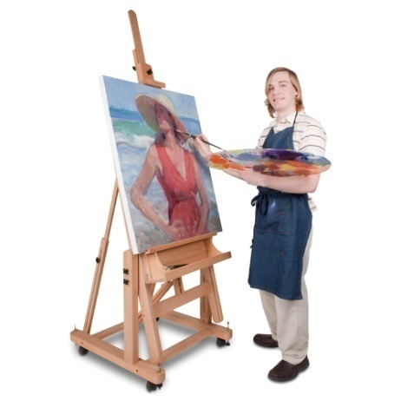

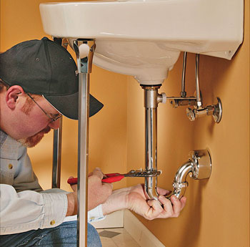

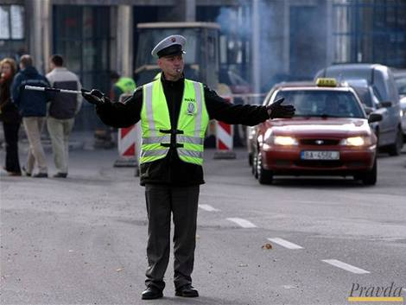

Example.:
A:The policeman should be/should have /must show a lot of ...........because..........
B: I AGREE BUT.............

- Make a tick if you agree
 | priest | policeman | doctor | artist | teacher
Creative
Sense of Humour
Presentation Skills
Calmness
talented
Inspirational
Passion, passionate in his job
Willing to Learn
intelligence
organizational skills
good communicator
courage
diplomatic skills
Perseverance
strong work ethic
balanced person
can think fast on their feet
make good decisions in a tough situation
doesn't get mad when people are rude, crude, or mean
needs to know the law
concentration
have to be in good physical shape
Intolerance of corruption
Teamwork
cares for people and not just for their money.
looks at the whole person and not just the simple complaint
knowledgeable
respectful
Ability to work hard and smart
Passionate about customer service
Highly self-motivated
Warm, friendly and engaging personality.
Cooperative

1.C Which types of work described above are manual and which of them are non-manual?
- Manual type of work is:...................................................................................................
.........................................................................................................................................
- Non-manual type of work is ...........................................................................................
.........................................................................................................................................
- One of the most interesting jobs is ................................................................................
........................................................................................................................................
- One of the most dangerous jobs is ................................................................................
.........................................................................................................................................
- The well-paid jobs are ....................................................................................................
- The badly-paid jobs are....................................................................................................
2. Use the word given in capitals at the end of each line to form a word that fits in the space in the same line.
Leaving a job
I recently left my job in an ....advertising ......agency ADVERTISEMENT
after a disagreement with my boss. She accepted my
........................but warned me that because of the RESIGN
.........................situation, I might have to get used to the ECONOMY
idea of being ..........................for a while. I thought that she EMPLOY
was trying to make a point, but after I had made over
fifty............................to other companies, I realized that she APPLY
was right. Although I am a.............................designer, I QUALIFICATIONS
didn´t receive any offers for a job. After I had tired
working from home, but it was not very......................... PROFIT
Then I became an........................in a fast-food restaurant, EMPLOY
Even though my ........................were extremely low. EARN
I wish I had accepted early.........................from my old job. RETIRE
That is what I disagreed with my boss about!

3. These are the top ten skills most valued by employers in today´s job market:

SKILL RANK WHY?
Communication skills………………………………………………………………………………………………………………
Honesty/integrity……………………………………………………………………………………………………………………
Teamwork skills………………………………………………………………………………………………………………………
Interpersonal skills………………………………………………………………………………………………………………….
Strong work ethic……………………………………………………………………………………………………………………
Motivation/initiative………………………………………………………………………………………………………………
Flexibility/adaptability……………………………………………………………………………………………………………
Analytical skills……………………………………………………………………………………………………………………….
Computer skills……………………………………………………………………………………………………………………….
Organizational skills………………………………………………………………………………………………………………..

4. MY QUALITIES AND FLAWS? Write 5 sentences about your positives and negatives – vices and virtues:

…………………………………………………………………………………………………………………………………………………………………………………………………………………………………………………………………………………………………………………………………………………………………………………………………………………………………………………………………………………………………………………………………………………………………………………………………………………………………………………………………………………………………………………………………………………………………………………………………………………………………………………………………………………………….
……………………………………………………………………………………………………………………………………………
…………………………………………………………………………………………………………………………………………..

IDIOMS CONNECTED WITH SPEAKING

5. Idioms . Look at the highlighted idioms and try to guess their meanings.
Match the idioms with their meanings.
- My boss is rather a cold fish. I don’t even know if he likes me or not.  - She has a heart of gold. She’ll always help anyone with anything.  - She’s as hard as nails. She doesn’t care who she hurts.  - I hope Jack doesn’t come tonight. He’s such a pain in the neck. | A) annoying, difficult  B) very kind, generous  C) distant, unfriendly  D) shows no sympathy or fear

TALK IN DISCUSSIONS, MEETINGS ...

What does it mean? Find explanations:

I hope Will speaks, he always talks sense
Who´s going to start the ball rolling?

I hope they get to the point soon.

Iris always talks rubbish

I want to speak my mind today.

Peter is so long-winded.

I hope we wrap up the discussion by 12.30
To put it in a nutshell, this is a waste of time.

1 start the discussion 5 finish the discussion
2 say it in a few words 6 says inteligent, reasonable things
3 come to the important part of the mater 7 says stupid things
4 say exactly what I think 8 says thing in a long, indirect way

